Report

understanding about the dataset
This dataset is the Customer Support posts from the biggest brands like ‘apple support’, ‘amazon help’ , ‘uber support’ on Twitter. The data stored in a csv file, each row consists of tweet_id, author_id, inbound, create data, text etc. They are either new post or response to the exist post.

Using different preprocessing steps
• Tokenization
• Stop words removal
• Stemming
• Lemmatization
• And other pre-processing tasks

various pre-processing steps
Load data
Load data into panda dataframe for easy interpretation

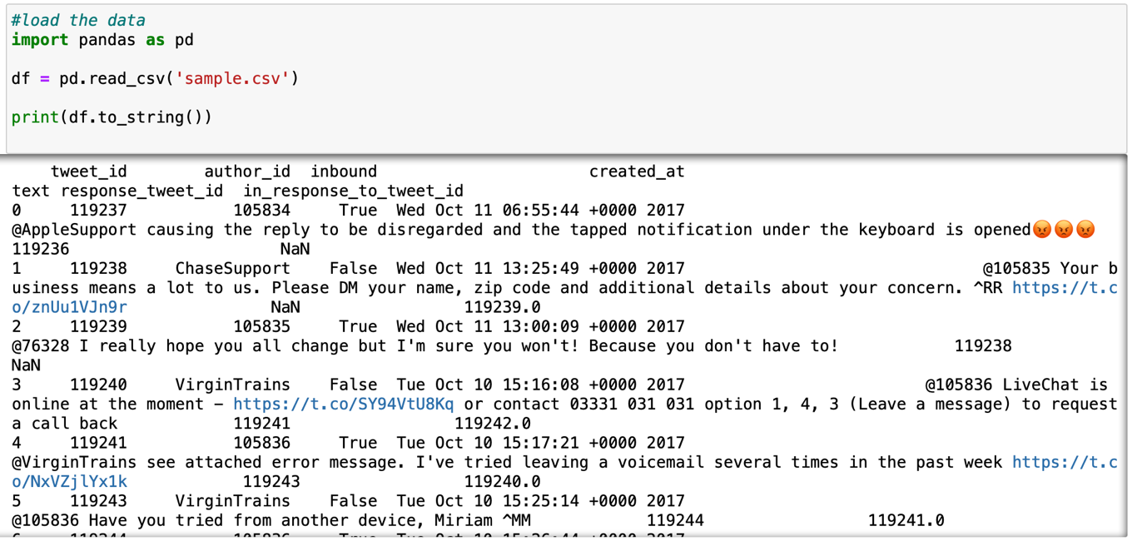

Tokenization
Convert the data into small token instead of the paragraph, it immediately turns an unstructured string into a numerical data structure suitable for machine learning.

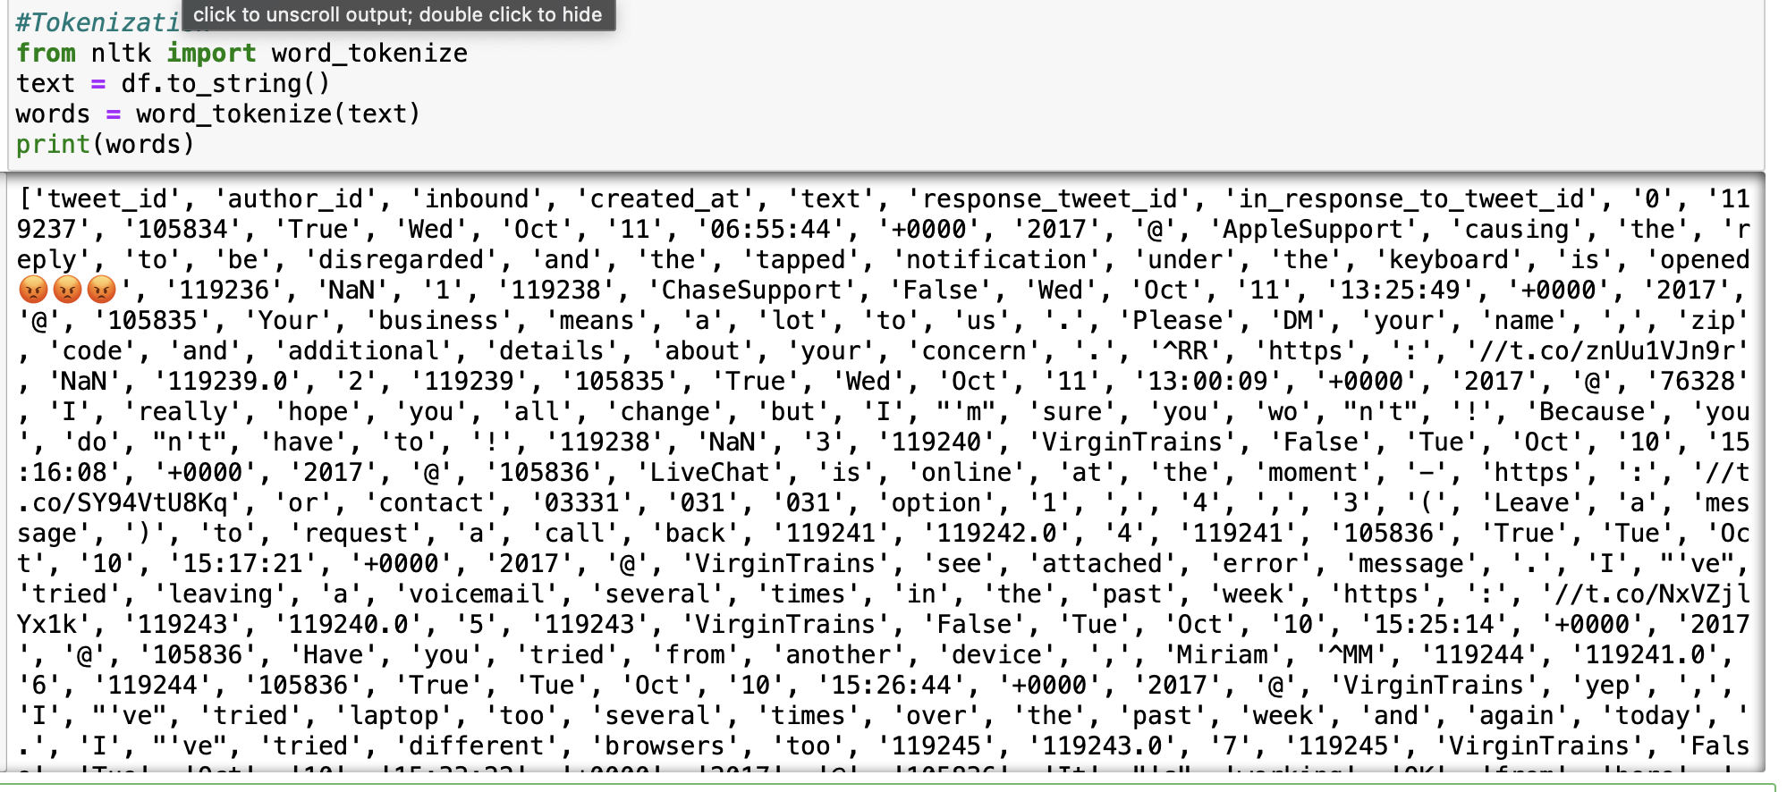

Lower casing

Apply lower casing of each word by for loop
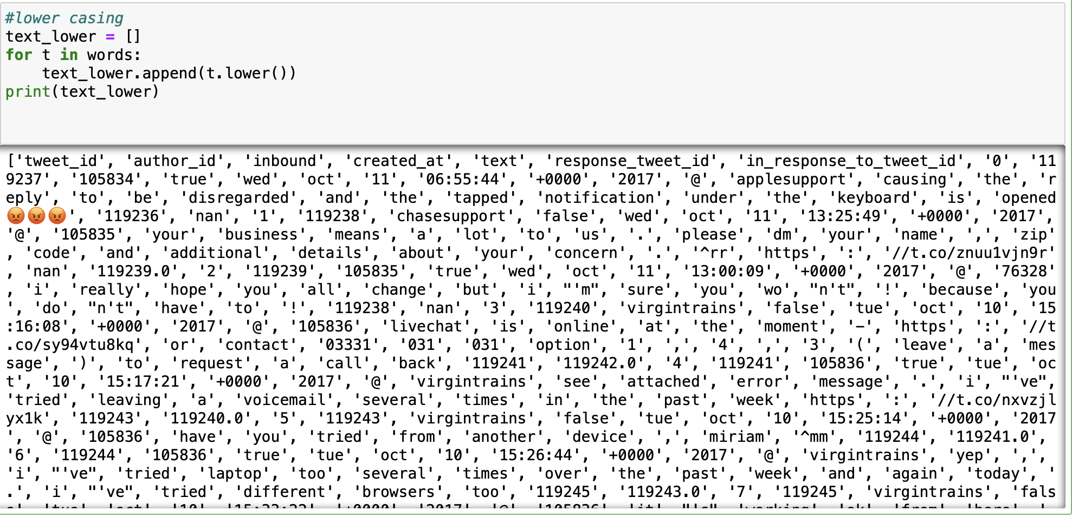

Removing Punctuations
Punctuations serve little value to the analysed data, therefore we remove them in the pre processing step.
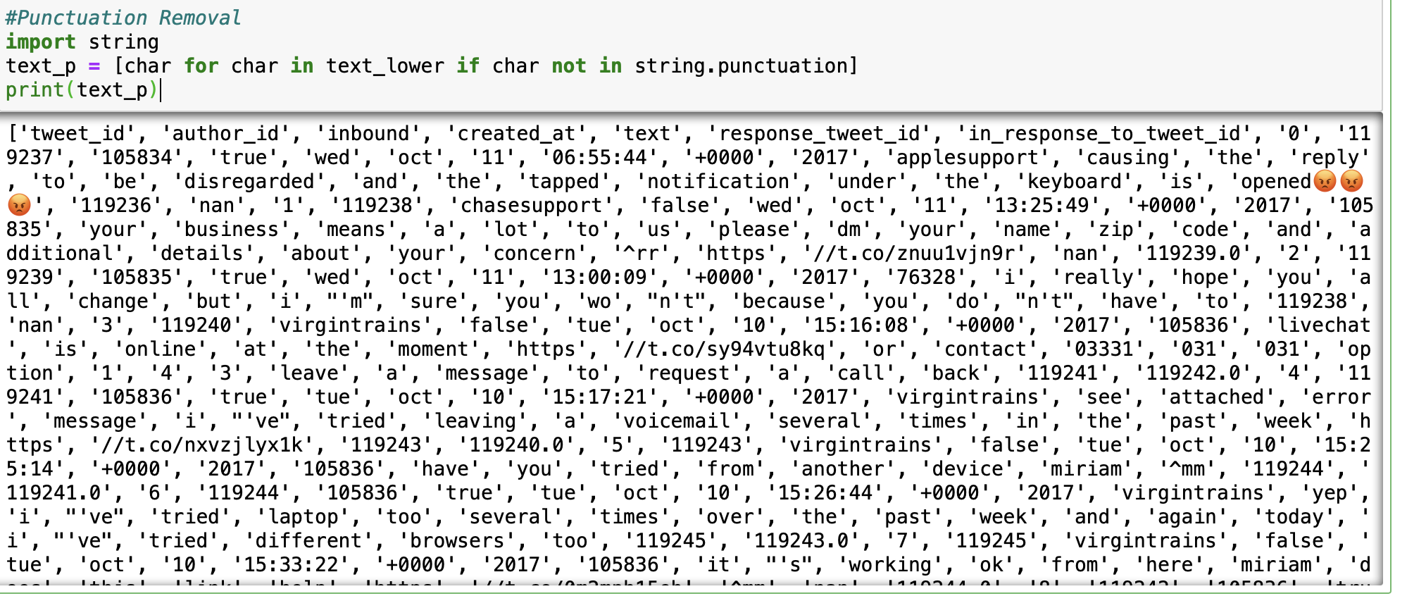

Removal of stop words

Stopwords are usually do not add much meaning to a sentence, therefore, we remove them for easier analysis. In the English language common stopwords include “you, he, she, in, a, has, are, etc.

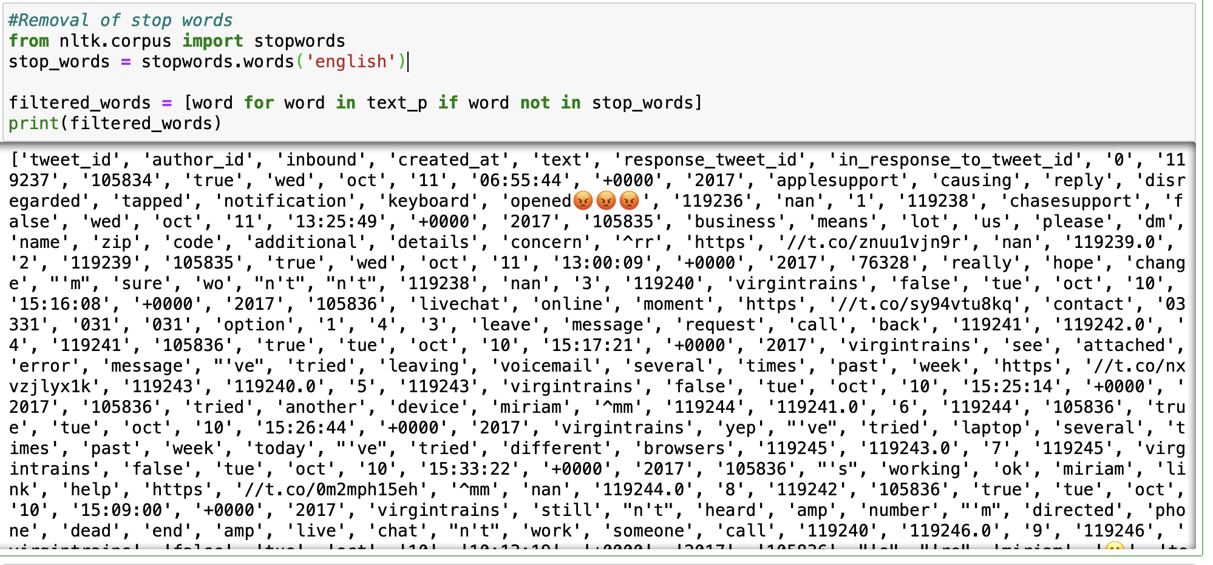

Stemming and Lemmatization

Stemming is converting the word into its base form whereas lemmatization will find the morphological root of a word

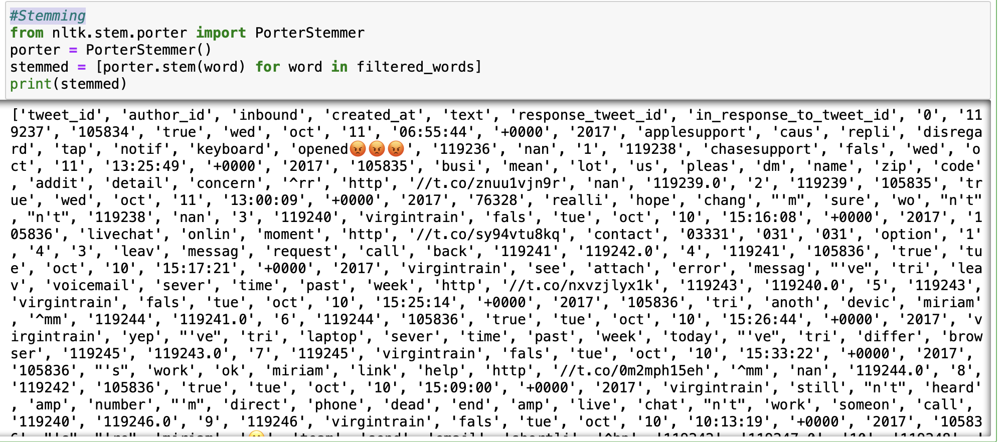
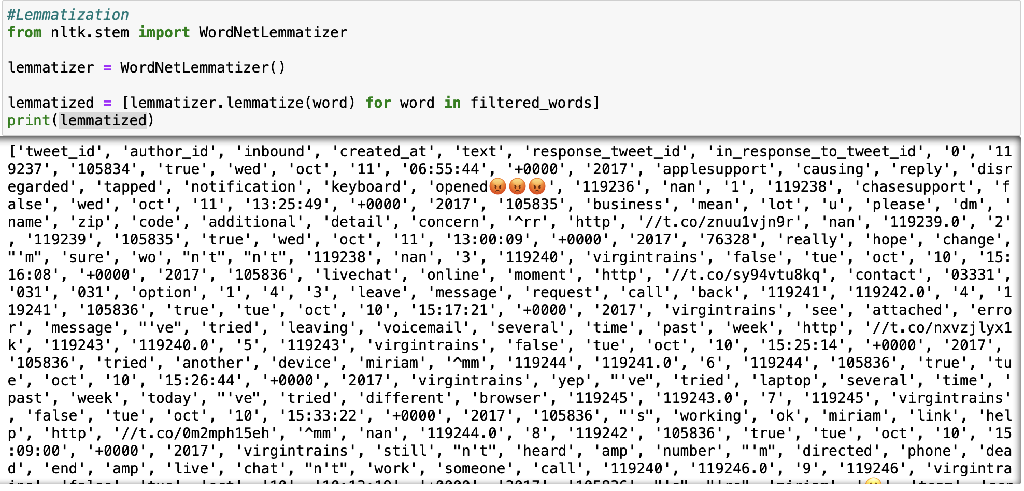

Removal of emojis, emoticons, and URLs

Join the tokens into string to apply regular expression method.
Remove emojis , use regular expression method to find the emojos in uni code and remove them.

Remove emoticons, it has been removed when we remove punctuations before.

Remove URL, because the string has been tokenized before, the url breaks into two parts, remove the word ‘http’ and remove any string begin with //.

